21.7: a) Using Coulomb’s Law for equal charges, we find:
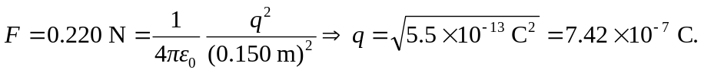

b) When one charge is four times the other, we have:
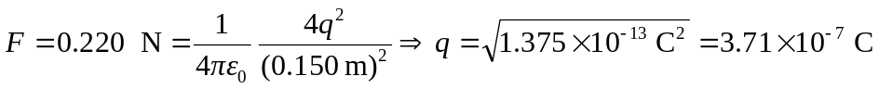
So one charge is 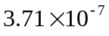 C, and the other is 